# First Interim - Plan and Schedule

## Systems Lifecycle Model

The project will use the Dynamic Systems Development Method (DSDM). DSDM belongs to the group of Agile software development methods. It takes an ‘iterative and incremental’ approach to software development, ensuring through frequent communication with the client that the end-product is exactly as required (*although there is no actual customer involvement in the development, feedback will come from peers and tutors during labs for the WEBSCRP unit*). DSDM enables setting a fixed time for the project (*which will be according to project delivery deadlines*) and using this time and the MoSCoW method will ensure that all core features are completed to a good standard as a priority whilst still planning time to implement more ‘optional’ features and allowing the project to adapt to the changing needs of the client. Additionally, this method allows constant development and improvement and therefore some features will potentially be left out of the ‘final’ coursework deployment and will be implemented in later releases of the project.

## Factors Affecting Implementation

There are a number of factors and risks that are important to consider beforehand:

* Work, classes and other coursework
  + I plan as much as possible every week in advanced; planning times to work on all coursework around my job and other classes on my course. This will ensure that I have sufficient time to complete this project as required, but I will also have to be realistic in the features that will be possible to implement in the given timeframe
* Unexpected complexity/difficulty in implementation, particularly in additional features
  + Development model allows for this as it focuses on completing core functionality first
  + Will also utilise help available through course tutorials and online and offline resources
* Data loss
  + Frequent saving & backups in 3 separate locations (USB drive, home PC, university network drive)
* Skills learnt from elsewhere will also assist in this project:
  + INSE unit will help in better project management and also assist in learning technical skills related to web technologies (i.e. HTML, CSS, MySQL, PHP, JavaScript)

## Gantt

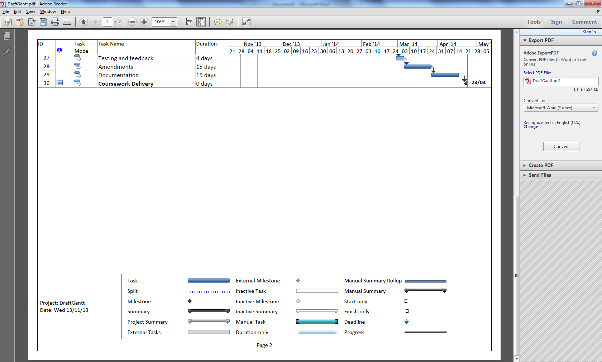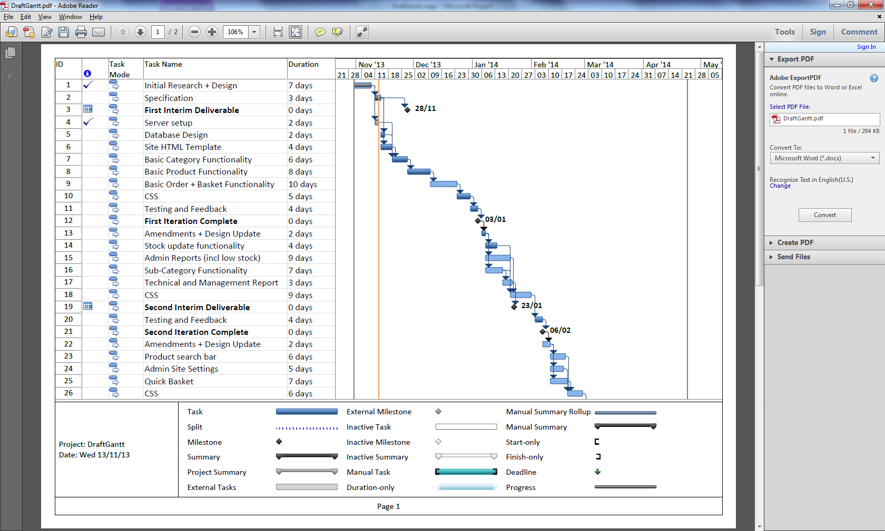

# Specification

The proposed functionality of the product upon delivery at the coursework deadline is as follows:

## End-User (Customer)

* Browse sub-categories by clicking on parent categories in sidebar
* Browse products by category/sub-category
* Search for items by keywords in product name or description
* Sort items (alphabetically, by price)
* Add products to basket
* View quick basket (summary of basket and basket cost) from any customer page
* View basket page (all items with descriptions, individual costs and total cost of all items in basket)
* Place orders (based on products in basket)

## Product/Catalogue Management (CMS)

This section is intended for use by potential clients’ staff to use in order to implement changes to the product catalogue:

* Add product (Name, Image, Description, Price, Stock Level)
* Update/Delete product
* Update product stock level
* Add/update/delete category

## Admin

This section is intended for use by clients’ staff but possibly at a different level to those with access to the CMS:

* View reports (total income, total orders, popular products, product stock levels)
* View order details
* Mark open orders as dispatched/complete
* Customise site settings

# Wireframe.pngWireframe